WATER SAFETY PLAN

Example text in yellow

Rural water supply system

Including climate considerations

[Name of water supply system]

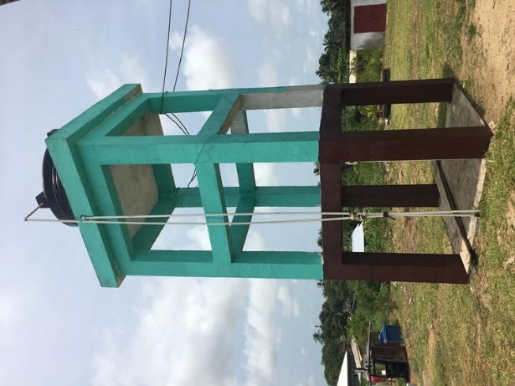

Version:
[XX]

Last Updated:
[DD/MM/YYYY]
Contents

Overview of the Water Safety Plan Steps 3
1 Water Safety Plan Team (Step 1) 4
2 Water System Description (Step 2) 6
3 Hazard and Control Measure Identification, Risk Assessment and Prioritization (Step 3) 8
4 Improvement Plan (Step 4) 17
5 Monitoring Plans (Step 5) 20
5.1 Operational monitoring plan 20
5.2 Verification monitoring plan 26
6 Water Safety Plan Documentation, Review and Improvement (Step 6) 27
6.1 Management procedures 27
6.2 WSP supporting programmes 28
6.3 WSP review/revision meetings 29

Annex 1 Standard Operating Procedure Template 30
Annex 2 Emergency Response Plan Template 31
Annex 3 WSP Assessment Template 32

Important note:

Please print additional sheets as needed to complete each step.

Overview of the Water Safety Plan Steps

The following figure gives a summary of the steps (or tasks) involved in the WSP process.
This WSP template follows each of these steps in the same order.

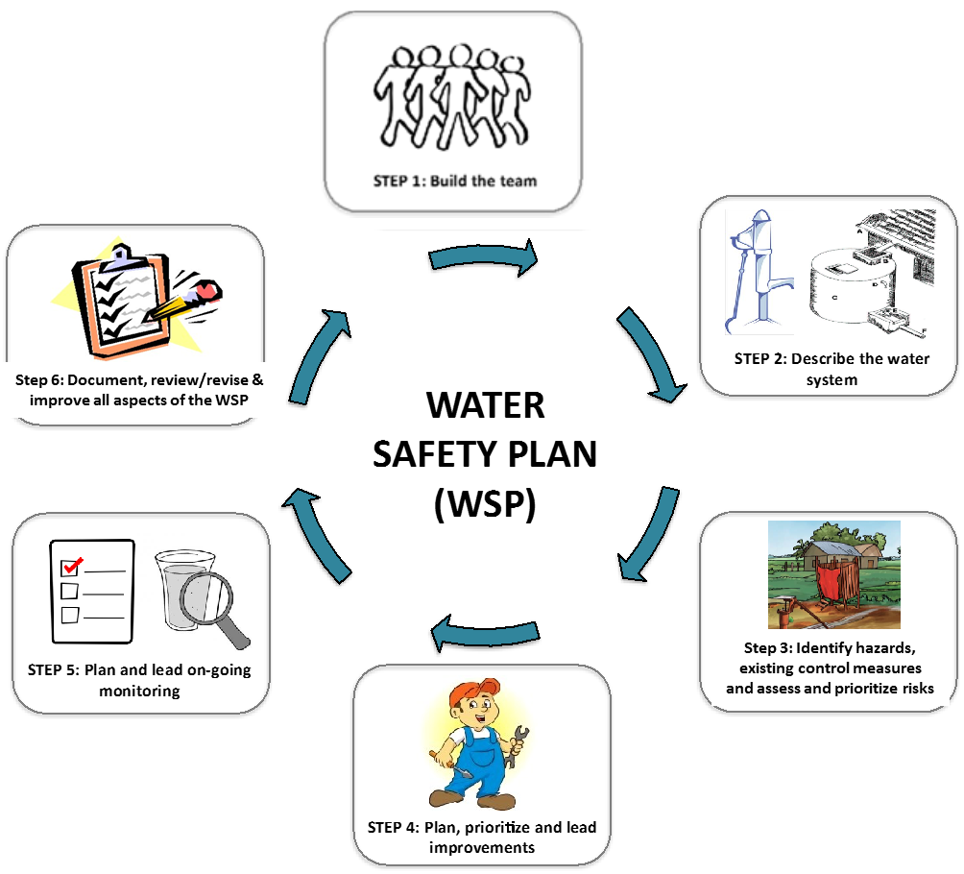

Water Safety Plan Team (Step 1)

Key action: Document the details of the WSP team members and outline their key
role and responsibilities. Consider what additional expertize may be required to support the integration of climate impacts into your WSP.

The core duties of the WSP Team are as follows:
- Engage with the community and stakeholders to ensure community water supply/quality needs are reflected in the WSP, and to create support and motivation for WSP develop and implementation (STEP 1)
- Create a map showing drinking water supply from catchment to consumer and fill in the system information table (STEP 2); consider the current/predicted climate impacts on the water supply system
- Identify hazards and assess the effectiveness of existing control measures, and assess and rank risks to water safety from the catchment to consumer (STEP 3); consider the impact of current/predicted climate change on the profile of existing risks, as well as any new risk that may be introduced
- Plan, prioritize and lead improvements to water system components to manage current risks, as well as predicted risks that may arise from climate change (STEP 4)
- Plan and lead on-going monitoring of water system components including household practices (STEP 5)
- Document management procedures (including emergency response plans to manage current/predicted climate events); meet routinely to check that WSP activities are being carried out as planned and the WSP is working effectively, and to make updates and changes to the WSP if necessary (STEP 6)
- Plan and lead on-going supporting activities to educate staff, households and the general community about safe water practices (STEP 6); consider what supporting programmes may be required to support climate resilient WSP activities.

[Add additional responsibilities as required]

WSP Team Table:

Name | Job title | Organization | Role on the WSP Team | Contact information
Mr. X | Caretaker | Water & Sanitation Management Team | Water supply system operation and maintenance | Ph. 01 234 5678 email@email.com

Note: Use additional sheets as needed.

Water System Description (Step 2)

Key action: Briefly describe in words, and in a drawing, the water system from the catchment/source right through to the
point of use by the consumer. Include relevant climate considerations at each process step.

Describe the general conditions of the catchment (e.g. forested, agricultural), the source(s) of water (e.g. dug well, borehole, river), the water users/uses, and the number of people served. Include current/predicted climate considerations (e.g. rain fall, flooding zones, water quality impacts, drought, alternative water supplies etc.) | Describe if any treatment (e.g. sedimentation, clarification, filtration, chlorination, UV) of the source water occurs before consumer distribution/ collection. | Describe any centralized water storage, and how people collect and transport the water (e.g. piped to house, piped to tap stand, handpump & carry by hand, water carter, kiosk etc.). Consider how the current/predicted climate considerations may influence these practices. | Make a list of the different ways people treat (e.g. boiling, filtration, chlorine tablets) and store (e.g. in a household tank, jerry can, open bucket etc.) drinking-water at the household level (if practiced). Consider how the current/predicted climate considerations may influence these practices.
Catchment:  - Human settlements with limited sanitation facilities  - Etc.  Source:  - Surface water (river); dug well  - Etc.  Climate considerations:  - Current impacts include more severe rain fall events  - Future impacts include shortening of the dry season and increased annual rain fall  - Etc. | Chlorination (1% solution prepared from bleaching powder).  Etc. | Concrete storage tank  - 200 kL  - Built 1975  - Closed tank  - Cracked walls.  Collection by consumers at tap stands (three tap stands in the town).  Consumers collect water in open buckets to bring back to households.  With predicted increase in annual rainfall, consumer likely to switch to rain water harvesting to save water tariffs.  Etc. | No household treatment.  Household water stored in large open ceramic pots (no lid generally), on ground level and dedicated to water storage.  Use of dipping tool varies (e.g. cup, hand, ladle).  During floods, consumers cannot access tap stands, so will likely rely on flood water or rainwater harvesting (if it is in place).  Etc.
Use additional space as needed
Map of the water supply system: Draw a basic map of the water supply system. Include any activities in the catchment (e.g. agriculture, industry, human settlements), the source(s) of the water (e.g. well, river, bore), any centralized treatment steps (e.g. filtration, chlorination), any storage or distribution infrastructure (e.g. tanks, pipelines), any collection points (e.g. tap stands, hand pumps, kiosks), collection practices, household water treatment and storage practices and any other information that may be relevant to water quality and hazard identification. Include relevant climate considerations for each process step.

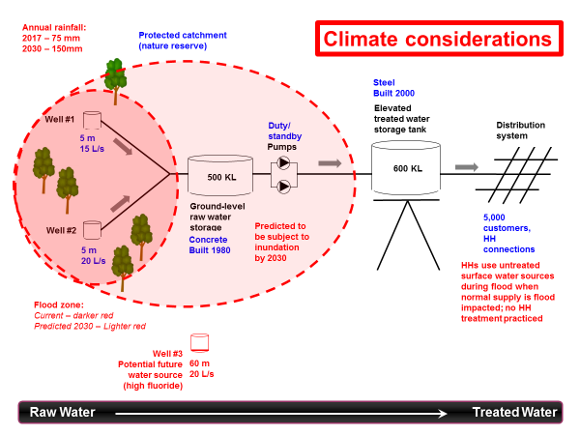

Hazard and Control Measure Identification, Risk Assessment and Prioritization (Step 3)

Key actions: At each step of the water system:
- Identify the possible dangers to water safety (i.e. hazards/hazardous events) that may impact water quality and community health
- Assess the effectiveness of any existing control measures that are in place to manage these risks, and
- Rank (prioritize) the significance of each risk accordingly.

Based on the current/predicted climate considerations described in the system description (Step 2), consider (1) the impact on existing hazards/hazardous events and (2) any new hazards/hazardous events that may arise from these predictions.

Risk assessment approach (descriptive risk assessment):

The WSP team should consider how likely a hazardous event is to occur and how serious it might be (given the effectiveness of the existing control measures if present), and assign a risk level.

Definition of risk level:

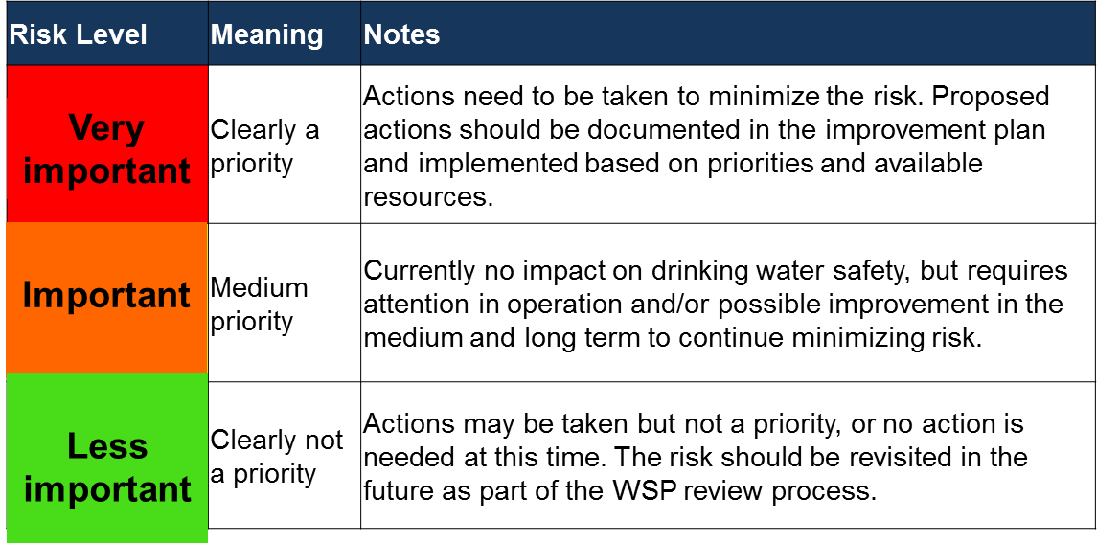

Note: Use additional sheets as needed.

1. Hazardous event | 2. Hazard | 3. Existing control measures | 4. Risk assessment | 5. Additional control measures
What can go wrong?  List what hazardous events could happen that might introduce hazards to your system and may make your drinking-water unsafe.  Use the formula: X happens to the water supply because of Y | If this does go wrong, what hazard(s) might be introduced into the water?  M = Microorganisms  C = Chemical  P = Physical  Q = Quantity | What existing control measures (i.e. barriers to contamination) are in place to prevent this (if any)?  If present, are the control measures working effectively? | How important is this event to water safety (i.e. how often is it likely to happen and what are the consequences if it does happen)?  Very important: requires urgent attention and action  Important: requires attention and action may be taken  Less important: no action required at this time. | Are additional control measures needed?  If yes, please state what additional control measure(s) are needed and include in Section 4.
Catchment/source
Faecal contamination of the source water due to flooding of the well | Microbial | None | Very important  Likelihood: Very likely due to shallow well and location in low lying area and climate prediction for increased annual rainfall.  Consequence: Faecal contamination can result in widespread public health impacts. | Yes.  - Build flood defense wall around existing wells  - Drill future alternative deep well outside of the flood zone (consider new requirement for fluoride removal from new well)
Catchment/source (continued)
Treatment (if any)
Treatment (if any; continued)
Storage/distribution/collection
Storage/distribution/collection (continued)
Point of use (household treatment, storage and handling)
Point of use (household treatment, storage and handling; continued)

Improvement Plan (Step 4)
Key action: Document the details of the additional control measures needed that were identified in Step 3 (Column 5).

 | What improvement is needed?  (From Column 5 of the  table in Section 3) | What is the priority level? (High/medium/low) | Who is responsible for coordinating the completion of this improvement? | How much is it estimated to cost? | Where will the budget come from? | Planned  start date? | Planned finish date? | Status?
1 | Build flood defense wall around existing wells 1 and 2 | High | Community water supply authority | 2000 USD | Regional infrastructure budget | June 2017 | August 2017 | Underway
2

3

4

5

6
7
8
9
10
11
Note: Use additional sheets as needed.

Monitoring Plans (Step 5)
Key actions: Document the details of the plan for (1) monitoring of the existing control measures identified in Step 3 (Column 3; i.e. operational monitoring plan) and (2) verifying that the WSP is working effectively (i.e. verification monitoring plan).

Operational monitoring plan (use additional sheets as needed)

Control measure  (from Column 3 in Step 3) | How will this existing control measure be monitored/inspected? |  | When is the control measure considered to be not working? | What needs to be done if the control measure is not working?
Drainage ditch to divert pig farm flow from entering the river | What needs to be monitored? | Condition of the drainage ditch | When the diversion ditch is clogged and/or overflowing. | - Notify WSP team leader  - Stop harvesting raw water from the river  Remove material from drainage ditch as soon as possible.
 | How will it be monitored? | Visual inspection
 | When will it be monitored? | Dry season – monthly  Wet season – weekly
 | Where will it be monitored? | At the pig farm perimeter
 | Who will monitor it? | Caretaker
 | What needs to be monitored?
 | How will it be monitored?
 | When will it be monitored?
 | Where will it be monitored?
 | Who will monitor it?
 | What needs to be monitored?
 | How will it be monitored?
 | When will it be monitored?
 | Where will it be monitored?
 | Who will monitor it?
 | What needs to be monitored?
 | How will it be monitored?
 | When will it be monitored?
 | Where will it be monitored?
 | Who will monitor it?

Control measure  (from Column 3 in Step 3) | How will this existing control measure be monitored/inspected? |  | When is the control measure considered to be not working? | What needs to be done if the control measure is not working?
 | What needs to be monitored?
 | How will it be monitored?
 | When will it be monitored?
 | Where will it be monitored?
 | Who will monitor it?
 | What needs to be monitored?
 | How will it be monitored?
 | When will it be monitored?
 | Where will it be monitored?
 | Who will monitor it?

Control measure  (from Column 3 in Step 3) | How will this existing control measure be monitored/inspected? |  | When is the control measure considered to be not working? | What needs to be done if the control measure is not working?
 | What needs to be monitored?
 | How will it be monitored?
 | When will it be monitored?
 | Where will it be monitored?
 | Who will monitor it?
 | What needs to be monitored?
 | How will it be monitored?
 | When will it be monitored?
 | Where will it be monitored?
 | Who will monitor it?

Control measure  (from Column 3 in Step 3) | How will this existing control measure be monitored/inspected? |  | When is the control measure considered to be not working? | What needs to be done if the control measure is not working?
 | What needs to be monitored?
 | How will it be monitored?
 | When will it be monitored?
 | Where will it be monitored?
 | Who will monitor it?
 | What needs to be monitored?
 | How will it be monitored?
 | When will it be monitored?
 | Where will it be monitored?
 | Who will monitor it?

Control measure  (from Column 3 in Step 3) | How will this existing control measure be monitored/inspected? |  | When is the control measure considered to be not working? | What needs to be done if the control measure is not working?
 | What needs to be monitored?
 | How will it be monitored?
 | When will it be monitored?
 | Where will it be monitored?
 | Who will monitor it?
 | What needs to be monitored?
 | How will it be monitored?
 | When will it be monitored?
 | Where will it be monitored?
 | Who will monitor it?

Verification monitoring plan (use additional rows as needed)

What needs to be checked? | What locations will be checked? | How often? And how many samples will be taken? | Who will do the checking? | What is the target outcome? | WSP team member to report the outcome to?
Water quality testing (compliance monitoring) (e.g. E. coli, faecal coliforms, turbidity)
E. coli | Household storage container (1 household per month) | Monthly | Environmental Health Assistant | 0 E. coli/100 mL | WSP Team Leader
Sanitary inspection (e.g. at source, collection point, household etc.)
Sanitary condition | Storage tank | 1 survey per month | Environmental Health Assistant | “Low” risk score | WSP Team Leader
 | Tap stand | 1 survey per month | Environmental Health Assistant | “Low” risk score | WSP Team Leader
 | Household collection/storage containers | 3 households per month | Environmental Health Assistant | “Low” risk score | WSP Team Leader
WSP implementation (e.g. WSP assessment [see Annex 3])
Implementation of WSP | Whole WSP (source to household) | 1 audit per year | District Environmental Health Officer | Audit pass | WSP Team Leader
Consumer satisfaction (e.g. satisfaction survey)
Level of consumer satisfaction | Households | Performed once per year; covering 25 households | District Environmental Health Officer | “High” level of customer satisfaction received from 80% of households | WSP Team Leader

Water Safety Plan Documentation, Review and Improvement (Step 6)
Key actions:
- Document key management procedures and emergency response plans (including climate related emergencies).
- Plan supporting programme for on-going education & awareness raising for the WSP team & community (including programmes that support climate resilient WSP activities).
- Review the WSP (both routinely and following incidents/emergencies) to check that it is up-to-date and accurate; revise the WSP as necessary.

Management procedures
Templates for Standard Operating Procedures (Annex 1) and Emergency Response Plans (Annex 2) may be found in the annexes. Complete these as required and store in a folder alongside the WSP, and in the field as required. Consider the type of emergency situations that may arise from current/predicted climate impacts and develop emergency response plans to manage these events.

WSP supporting programmes

Key action: Document the details of a supporting programme for on-going education & awareness raising for the WSP team & community. Consider the type of supporting programmes that may be needed to support the management of current/predicted climate related risks that have been identified.

What specific supporting activity will be carried out? | How often will the activity be carried out? | Name of the person in charge of this activity?
Water safety awareness during an emergency, such as a flood | Six monthly | Ms. Y
Note: Use additional sheets as needed.

WSP review/revision meetings
Key action: Document any key information from WSP review meetings

Date of WSP review meeting | Reason for meeting (e.g. routine or post incident/emergency) | Participants present | Topics discussed | Key outcomes/ actions | Person responsible | Date completed
1 Oct. 2016 | Routine monthly meeting. | Mr. X  Ms. Y  Ms. Z | Status of improvement plan implementation. | District Technical Team to be updated on improvement plan implementation | Mr. X | Open
Note: Use additional sheets as needed.

Annex 1 Standard Operating Procedure Template

To document step-by-step instructions for carrying out routine tasks in your water supply system, use the following template. (Note: use additional sheets as needed.)

Task to be completed | Frequency | Instructions | Person responsible
Inspection of the pig farm diversion ditch | Dry season – monthly  Wet season – weekly | - Start inspection at the east end of the pig farm  - Walk along the drainage ditch from east to west until you reach the west end of the farm perimeter  - Visually check the diversion ditch for obvious signs of clogging (e.g. branches, sediments etc.) or damage to the diversion ditch banks.  If the diversion ditch appears to be clogged/obstructed/damaged/overflowing, report to the WSP team leader immediately. | Caretaker

Annex 2 Emergency Response Plan Template

To document your actions in response to an emergency situation, use the following template (Note: use additional sheets as needed.)

Possible emergency situation(s) | Detection of faecal contamination (E. coli) in the treated water supply following flood.
Steps to be taken to protect the water supply/public health | Issue boil water advisory
Person(s) to be notified (internal and external) and method of notification | WSP team leader (Ph. 12345678)  Public health officer (Ph. 12345679)  Community leader (Ph. 12345670)  District health officer (Ph. 12345677)
Method of notifying the community | Public announcement.  Sign at tap stands.  Door to door visits.
Source of alternative water supply | None available.  Community to be advised to boil the water before consumption until further notice.

Annex 3 WSP Assessment Template

To carry out an assessment of the WSP, use the following template.

General information
District:

Water supply name:

Date of assessment:

Assessor(s):

Water supply type:
(e.g. point source [well, spring etc.], piped water supply, any treatment etc.)
Primary contact for the water supply system (name, contact details)
Overall WSP assessment summary:
(to be completed at the end)

WSP Assessment
# | Question | Assessment  (Good/Average/Poor) | Comments/Areas for improvement  (include reasons for your assessment mark and list any possible ways in which this area can be improved)
1 | Is the WSP team list current?
2 | Is the system description accurate and up-to-date?
3 | Is the hazard identification, control measure assessment and risk assessment understood and thorough?
4 | Is the improvement plan up-to-date and being implemented?
5 | Is operational monitoring being carried out as per the plan?
6 | Is verification monitoring being carried out as per the plan?
7 | If in use, are standard operating procedures and emergency response plans appropriate and being followed?
8 | Is the awareness raising plan appropriate for the needs of the staff/community and being implemented?
9 | Are the WSP team meeting routinely and the WSP being revised as appropriate?
10 | Are climate considerations integrated appropriately into the relevant steps?

-------------------------------------- -------------------------------------------------------------
Date Signature of assessor(s)

