*Example text is highlighted in yellow*

**WATER SAFETY PLAN**

**Urban water supply system (piped)**

Water Town

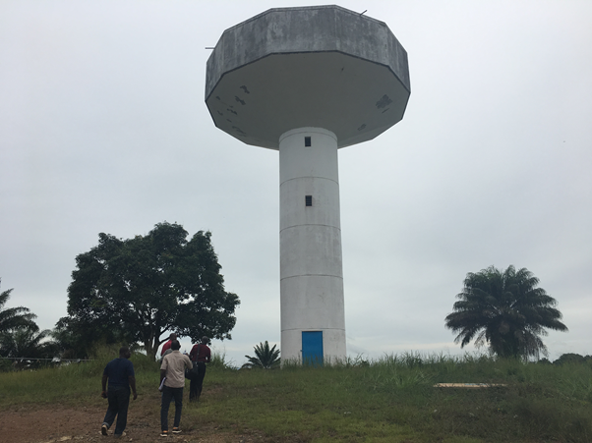

*Version:*

*01*

*Last Updated:*

*12/04/2017*

**Contents**

**Introduction 3**

**1) Water Safety Plan Team (Module 1) 4**

**2) Water System Description (Module 2) 5**

**3) Hazard and Control Measure Identification, Risk Assessment and Prioritization (Modules 3 & 4) 8**

**4) Improvement Plan (Module 5) 14**

**5) Operational Monitoring Plan (Module 6) 17**

**6) Verification Monitoring Plan (Module 7) 22**

**7) Management procedures (Module 8) 23**

**7.1 Standard operating procedures 23**

**7.2 Emergency response plans 23**

**8) Supporting programmes (Module 9) 24**

**9) WSP Review/Revision (Modules 10 and 11) 25**

**Annex 1 Standard Operating Procedure Template 26**

**Annex 2 Emergency Response Plan Template 27**

**Annex 3 WSP Assessment Template 28**

***Important note:***

**Please print additional sheets as needed to complete each step.**

# Introduction

A Water Safety Plan (WSP) is widely considered to be the most effective means of consistently ensuring the safety of a drinking-water supply[1]. A WSP follows a comprehensive risk assessment and risk management approach that encompasses all steps in water supply, from catchment to consumer, and it is a valuable tool to help water suppliers effectively operate and manage the water supply system.

***The following figure gives a summary of the 11 modules of the WSP process. This WSP follows each of these steps in the same order.***



# Water Safety Plan Team (Module 1)

***Key action: Document the details of the WSP team members and outline their key role and responsibilities, and contact details.***

***WSP Team Table***

|  |  |  |  |  |
| --- | --- | --- | --- | --- |
| ***Name*** | ***Designation*** | ***Organization*** | ***Role on the WSP Team*** | ***Contact information*** |
| Mr X | Manager Water Quality | Water Town Utility | WSP Team Leader | Ph. 284656969797  Email: [xmr@waterutility.ie](mailto:xmr@waterutility.ie) |
|  |  |  |  |  |
|  |  |  |  |  |
|  |  |  |  |  |
|  |  |  |  |  |
|  |  |  |  |  |
|  |  |  |  |  |
|  |  |  |  |  |
|  |  |  |  |  |
|  |  |  |  |  |

***Note: Use additional sheets as needed.***

# Water System Description (Module 2)

***Key action: Briefly describe in words, and in a diagram, the water supply system from the catchment/source right through to the***

***point of use by the consumer. Include any known or suspected water quality challenges.***

|  |  |  |  |
| --- | --- | --- | --- |
| **Describe the catchment** *(e.g. forested, agricultural, protected etc.),* **the source(s) of water** *(e.g. borehole, pond, river etc.)* **and the no. of people served, and any other relevant information** | **If there is any centralized water treatment facility present, describe the steps involved** (e.g. sedimentation, clarification, filtration, chlorination, UV, chemical used etc.) | **Describe the different kinds of water storages** *(if any*) **and how people receive or collect/transport the water** *(e.g. piped to premises, tap stand, kiosk, vendor etc.)* | **If practiced, describe how people treat** *(e.g. boiling, filtration, chlorine tablets/solution)* **and store** *(e.g. in a household tank, jerry can, open bucket etc.)* **drinking-water at the household level** |
| *Catchment:*   * Human settlements with limited sanitation facilities, open defecation, bathing/washing * Agriculture (pig farming, crops, irrigation, pesticide application, manure spreading) * No protection zones * Seasonal flooding   *Source:*   * Surface water (Blue river); pumped to 1 ML raw water storage (open) * Serves approx. 40,000 customers | Coagulation/flocculation (with aluminum sulphate dosing)  Filtration (rapid sand)  Chlorination (1% solution prepared from bleaching powder)  1 ML treated water storage | Treated water storage tank   * 500 kL * Built 1980 * Closed tank * Steel construct   Low level area: 20,000 customers (mixture of piped supply and tap stands)  High level area: 20,000 customers; piped supply directly to household  Consumers collect water in open buckets to bring back to households | No household treatment  Household water stored in large open ceramic pots (no lid generally), on ground level and dedicated to water storage  Use of dipping tool varies from household (e.g. cup, hand, ladle) |

**Map of the water supply system (Level 1)**

***Draw a basic overview of the entire water supply system. Include any activities in the catchment*** *(e.g. agriculture, industry, human settlements)****, the source(s) of the water*** *(e.g. well, river, bore)****, any treatment steps*** *(e.g. filtration, chlorination; referring to the Level 2 diagram on the next page for detail)*, ***any storage or distribution infrastructure*** *(e.g. tanks, pipelines)****, any collection points*** *(e.g. tap stands, kiosks),* ***household water treatment and storage practices and any other information that may be relevant to hazard identification.***

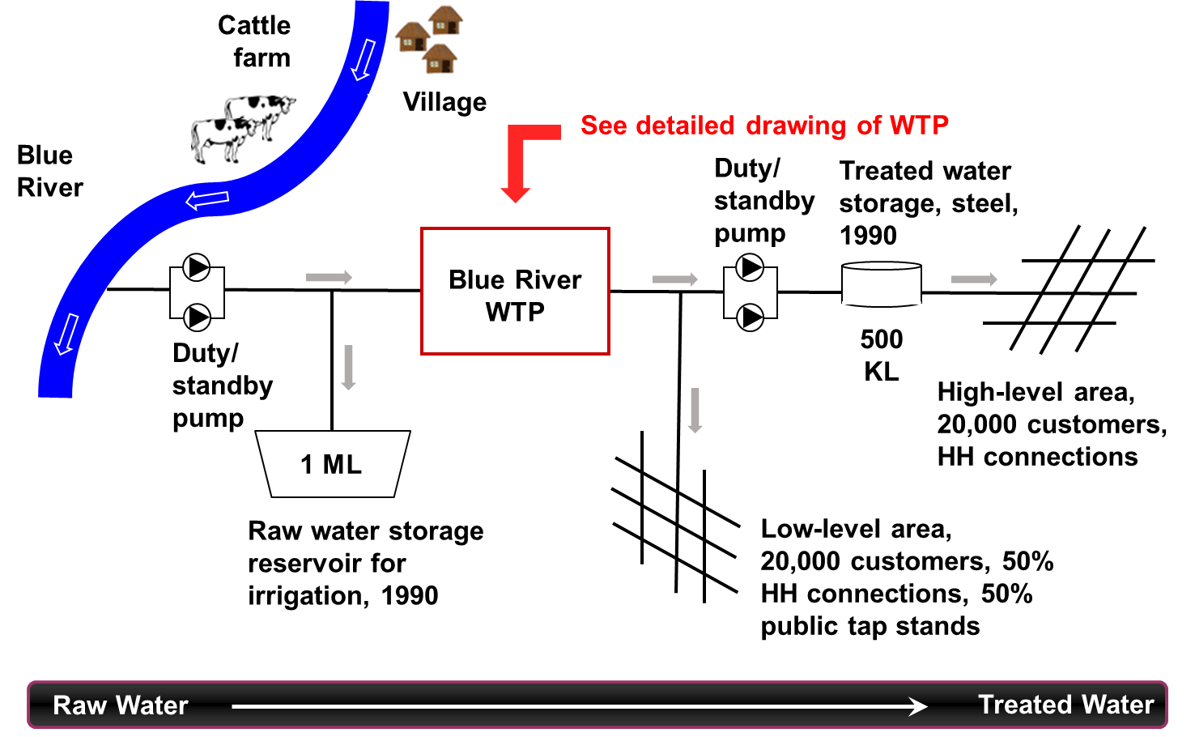

**Map of the water treatment facility (Level 2)**

***Draw a basic overview of the water treatment facility and the key treatment steps*** *(e.g., sedimentation, clarification, filtration, disinfection, chemical addition, treated water storage etc.)****. Include information on production capacity and the demand, the size of storage tanks, chemical addition points, pipe/tank materials, by-pass lines, sample points etc.***

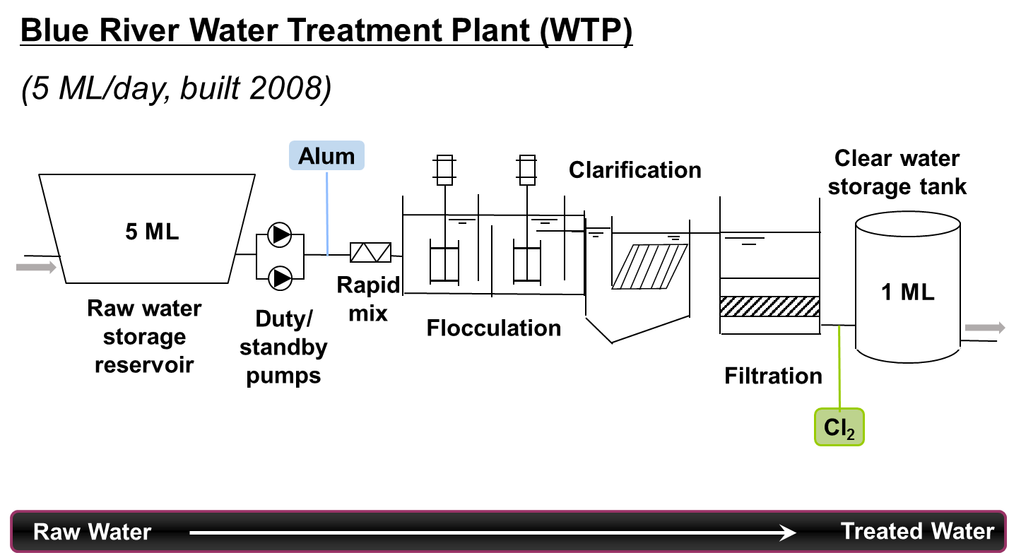

# Hazard and Control Measure Identification, Risk Assessment and Prioritization (Modules 3 & 4)

***Key action: At each step of the water system, identify the possible threats to water safety (i.e. hazards/hazardous events) that may impact water quality and the water supply system. Assess the effectiveness of any existing control measures that are already in place to manage these hazardous events, and assess and prioritize the risks.***

**Key terminology**

* A **hazard** is a biological, chemical or physical agent that has the potential to cause harm.
* A **hazardous event** is an event or situation that can introduce, or fail to remove, a hazard to the water supply system.
* **Risk** is the likelihood that a hazardous event/hazard will occur combined with the severity of the consequences.
* **Control measures** are activities or processes to prevent or reduce a hazardous event/hazard.
* **Validation** refers to reviewing evidence to determine whether or not the control measures can effectively control the hazardous event/hazard.

**Risk assessment approach (3 x 3 Matrix):**

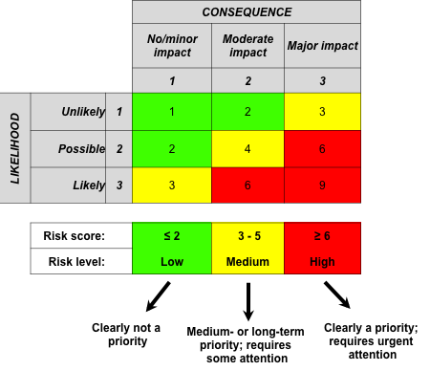

**Definition of likelihood and consequence:**





**Definition of risk level:**



***Risk assessment table:***

|  |  |  |  |  |  |  |  |  |  |  |  |  |  |  |
| --- | --- | --- | --- | --- | --- | --- | --- | --- | --- | --- | --- | --- | --- | --- |
| **Process Step**  *(catchment, source, treatment plant, etc.)* | **Hazardous Event**  *(“X happens because of Y”)* | **Hazard**  *(M, C, P)* | **Existing control measures** *(measures already in place)* | **Are these controls effective?** | | | | **Risk assessment** | | | | **Is additional control needed?** | | |
| **Yes** | **No** | **Somewhat** | **Validation notes** *(basis of control measure effectiveness decision)* | **Likelihood** | **Consequence** | **Risk score** | **Risk level** | **Yes** | **No** | **If yes, proposed controls** *(see improvement plan for detail)* |
| Catchment | Human effluent contaminating the water source water due to open defecation and run-off following heavy rain. | Microbial | Diversion ditch |  |  | X | Existing diversion ditch is somewhat effective as it is prone to clogging/ overflowing during heavy rain.  Water quality results often show *E. coli* present. | 2 | 2 | 4 | M | X |  | Establish a buffer zone of vegetation along the river bank. |

|  |  |  |  |  |  |  |  |  |  |  |  |  |  |  |
| --- | --- | --- | --- | --- | --- | --- | --- | --- | --- | --- | --- | --- | --- | --- |
| **Process Step**  *(catchment, source, treatment plant, etc.)* | **Hazardous Event**  *(“X happens because of Y”)* | **Hazard**  *(M, C, P)* | **Existing control measures** *(measures already in place)* | **Are these controls effective?** | | | | **Risk assessment** | | | | **Is additional control needed?** | | |
| **Yes** | **No** | **Somewhat** | **Validation notes** *(basis of control measure effectiveness decision)* | **Likelihood** | **Consequence** | **Risk score** | **Risk level** | **Yes** | **No** | **If yes, proposed controls** *(see improvement plan for detail)* |
|  |  |  |  |  |  |  |  |  |  |  |  |  |  |  |
|  |  |  |  |  |  |  |  |  |  |  |  |  |  |  |

|  |  |  |  |  |  |  |  |  |  |  |  |  |  |  |
| --- | --- | --- | --- | --- | --- | --- | --- | --- | --- | --- | --- | --- | --- | --- |
| **Process Step**  *(catchment, source, treatment plant, etc.)* | **Hazardous Event**  *(“X happens because of Y”)* | **Hazard**  *(M, C, P)* | **Existing control measures** *(measures already in place)* | **Are these controls effective?** | | | | **Risk assessment** | | | | **Is additional control needed?** | | |
| **Yes** | **No** | **Somewhat** | **Validation notes** *(basis of control measure effectiveness decision)* | **Likelihood** | **Consequence** | **Risk score** | **Risk level** | **Yes** | **No** | **If yes, proposed controls** *(see improvement plan for detail)* |
|  |  |  |  |  |  |  |  |  |  |  |  |  |  |  |
|  |  |  |  |  |  |  |  |  |  |  |  |  |  |  |
| **Process Step**  *(catchment, source, treatment plant, etc.)* | **Hazardous Event**  *(“X happens because of Y”)* | **Hazard**  *(M, C, P)* | **Existing control measures** *(measures already in place)* | **Are these controls effective?** | | | | **Risk assessment** | | | | **Is additional control needed?** | | |
| **Yes** | **No** | **Somewhat** | **Validation notes** *(basis of control measure effectiveness decision)* | **Likelihood** | **Consequence** | **Risk score** | **Risk level** | **Yes** | **No** | **If yes, proposed controls** *(see improvement plan for detail)* |
|  |  |  |  |  |  |  |  |  |  |  |  |  |  |  |
|  |  |  |  |  |  |  |  |  |  |  |  |  |  |  |

***Note: Use additional sheets as needed.***

# Improvement Plan (Module 5)

***Key action: Document the details of the additional control measures needed that were identified in Step 3 (last column).***

|  | ***What improvement is needed?***  *(From last column of the*  *table in Section 3)* | ***What is the priority level for the improvement?*** *(****High****/****medium****/****low****)* | ***Who is responsible for completion of this improvement?*** | ***How much is it estimated to cost?*** | ***What is the funding source?*** | ***When is this action due by (date)?*** | ***What is the status?*** |
| --- | --- | --- | --- | --- | --- | --- | --- |
| **1** | Establish a buffer zone of vegetation along the river bank. | **Medium** | Catchment management officer | 10,000 USD | Catchment Management Authority | December 2017 | In progress |
| **2** |  |  |  |  |  |  |  |
| **3** |  |  |  |  |  |  |  |
| **4** |  |  |  |  |  |  |  |
| **5** |  |  |  |  |  |  |  |
| **6** |  |  |  |  |  |  |  |
| **7** |  |  |  |  |  |  |  |
| **8** |  |  |  |  |  |  |  |
| **9** |  |  |  |  |  |  |  |
| **10** |  |  |  |  |  |  |  |
| **11** |  |  |  |  |  |  |  |

***Note: Use additional sheets as needed.***

# Operational Monitoring Plan (Module 6)

***Key actions: Document the details of the operational monitoring plan for the existing control measures identified in column 4 in the table in step 3***

**Operational monitoring plan (use additional sheets as needed):**

| ***Control measure***  *(from column 4 in Step 3)* | ***How will this existing control measure be monitored/inspected?*** | | ***When is the control measure considered to be not working?*** | ***What needs to be done if the control measure is not working?*** |
| --- | --- | --- | --- | --- |
| Drainage ditch to divert effluent from entering the river | ***What needs to be monitored?*** | Condition of the drainage ditch | When the diversion ditch is clogged and/or overflowing. | * Notify WSP team leader * Stop harvesting raw water from the river   Remove material from drainage ditch as soon as possible. |
| ***How will it be monitored?*** | Visual inspection |
| ***When will it be monitored?*** | Dry season – monthly  Wet season – weekly |
| ***Where will it be monitored?*** | At the pig farm perimeter |
| ***Who will monitor it?*** | Caretaker |
|  | ***What needs to be monitored?*** |  |  |  |
| ***How will it be monitored?*** |  |
| ***When will it be monitored?*** |  |
| ***Where will it be monitored?*** |  |
| ***Who will monitor it?*** |  |
|  | ***What needs to be monitored?*** |  |  |  |
| ***How will it be monitored?*** |  |
| ***When will it be monitored?*** |  |
| ***Where will it be monitored?*** |  |
| ***Who will monitor it?*** |  |
|  | ***What needs to be monitored?*** |  |  |  |
| ***How will it be monitored?*** |  |
| ***When will it be monitored?*** |  |
| ***Where will it be monitored?*** |  |
| ***Who will monitor it?*** |  |

| ***Control measure***  *(from Column 3 in Step 3)* | ***How will this existing control measure be monitored/inspected?*** | | ***When is the control measure considered to be not working?*** | ***What needs to be done if the control measure is not working?*** |
| --- | --- | --- | --- | --- |
|  | ***What needs to be monitored?*** |  |  |  |
| ***How will it be monitored?*** |  |
| ***When will it be monitored?*** |  |
| ***Where will it be monitored?*** |  |
| ***Who will monitor it?*** |  |
|  | ***What needs to be monitored?*** |  |  |  |
| ***How will it be monitored?*** |  |
| ***When will it be monitored?*** |  |
| ***Where will it be monitored?*** |  |
| ***Who will monitor it?*** |  |

| ***Control measure***  *(from Column 3 in Step 3)* | ***How will this existing control measure be monitored/inspected?*** | | ***When is the control measure considered to be not working?*** | ***What needs to be done if the control measure is not working?*** |
| --- | --- | --- | --- | --- |
|  | ***What needs to be monitored?*** |  |  |  |
| ***How will it be monitored?*** |  |
| ***When will it be monitored?*** |  |
| ***Where will it be monitored?*** |  |
| ***Who will monitor it?*** |  |
|  | ***What needs to be monitored?*** |  |  |  |
| ***How will it be monitored?*** |  |
| ***When will it be monitored?*** |  |
| ***Where will it be monitored?*** |  |
| ***Who will monitor it?*** |  |

| ***Control measure***  *(from Column 3 in Step 3)* | ***How will this existing control measure be monitored/inspected?*** | | ***When is the control measure considered to be not working?*** | ***What needs to be done if the control measure is not working?*** |
| --- | --- | --- | --- | --- |
|  | ***What needs to be monitored?*** |  |  |  |
| ***How will it be monitored?*** |  |
| ***When will it be monitored?*** |  |
| ***Where will it be monitored?*** |  |
| ***Who will monitor it?*** |  |
|  | ***What needs to be monitored?*** |  |  |  |
| ***How will it be monitored?*** |  |
| ***When will it be monitored?*** |  |
| ***Where will it be monitored?*** |  |
| ***Who will monitor it?*** |  |

***Note: Use additional sheets as needed.***

# Verification Monitoring Plan (Module 7)

***Key actions: Document the details of the verification monitoring plan for verification that the WSP is working effectively.***

**Verification monitoring plan (use additional rows or sheets as needed)**

|  |  |  |  |  |  |
| --- | --- | --- | --- | --- | --- |
| ***What needs to be checked?*** | ***What locations will be checked?*** | ***How often? And how many samples will be taken?*** | ***Who will do the checking?*** | ***What is the target outcome?*** | ***WSP team member to report the outcome to?*** |
| ***Water quality testing (compliance monitoring)*** ***(e.g. E. coli, faecal coliforms, turbidity)*** | | | | | |
| *E. coli* | Household (1 per month) | Monthly | Environmental Health Assistant | 0 *E. coli*/100 mL | WSP Team Leader |
|  |  |  |  |  |  |
| ***Sanitary inspection (e.g. at source, collection point, household etc.)*** | | | | | |
| Sanitary condition | Storage tank | 1 survey per month | Environmental Health Assistant | “Low” risk score | WSP Team Leader |
|  | Tap stand | 1 survey per month | Environmental Health Assistant | “Low” risk score | WSP Team Leader |
| ***WSP implementation (e.g. WSP assessment [see Annex 3])*** | | | | | |
| Implementation of WSP | Whole WSP (source to household) | 1 assessment per year | District Environmental Health Officer | Assessment pass | WSP Team Leader |
|  |  |  |  |  |  |
| ***Consumer satisfaction (e.g. satisfaction survey)*** | | | | | |
| Level of consumer satisfaction | Households | Performed once per year; covering 25 households | District Environmental Health Officer | “High” customer satisfaction from 80% of households | WSP Team Leader |

# Management procedures (Module 8)

***Key actions: Document key management procedures and response plans.***

## Standard operating procedures

Using the template provided in Annex 1, standard operating procedures (SOPs) should be developed for all routine operational tasks; for example:

* filter operation and maintenance
* chlorination
* jar testing
* water sampling
* water testing (for various parameters)
* storage tank cleaning
* pipeline repair practices
* pump operation and maintenance etc.

## Emergency response plans

Using the template provided in Annex 2, emergency response plans should be developed for emergency situations; for example:

* microbiological exceedance
* high turbidity event
* Loss of chlorination
* prolonged power outage
* boil water advisory
* alternative water supply arrangements etc.

# Supporting programmes (Module 9)

***Key action: Document the details of programmes for on-going education & awareness raising for the WSP team, stakeholders & consumers.***

|  |  |  |
| --- | --- | --- |
| ***What specific awareness-raising activity will be carried out?*** | ***How often will the activity be carried out?*** | ***Name of the person in charge of this activity?*** |
| e.g. Water safety awareness during an emergency, such as a flood; Household sanitation and hygiene; Community sanitation and clean-up campaigns; Household water treatment and safe storage; School education programmes; Water treatment operator/caretaker training programmes; Emergency drills for flooding events | Every 12 months | Ms. Y |
|  |  |  |
|  |  |  |
|  |  |  |

***Note: Use additional sheets as needed.***

# WSP Review/Revision (Modules 10 and 11)

***Key actions: Review the WSP (both routinely and following incidents/emergencies) to check that it is up-to-date and accurate.***

***Revise the WSP as necessary.***

|  |  |  |  |  |  |  |
| --- | --- | --- | --- | --- | --- | --- |
| ***Date of WSP review meeting*** | ***Reason for meeting (e.g. routine or post incident/emergency)*** | ***Participants present*** | ***Topics discussed*** | ***Key outcomes/ actions*** | ***Person responsible*** | ***Date completed*** |
| 1 Oct. 2016 | Routine monthly meeting. | Mr. X  Ms. Y  Ms. Z | Status of improvement plan implementation | District Technical Team to be updated on improvement plan implementation | Mr. X | Open |

***Note: Use additional sheets as needed.***

# Annex 1 Standard Operating Procedure Template

***To document step-by-step instructions for carrying out routine tasks in your water supply system, use the following template.***

|  |  |  |  |
| --- | --- | --- | --- |
| ***Task to be completed*** | ***Frequency*** | ***Instructions*** | ***Person responsible*** |
| Inspection of the diversion ditch | Dry season – monthly  Wet season – weekly | * Start inspection at the east end of the pig farm * Walk along the drainage ditch from east to west until you reach the west end of the farm perimeter * Visually check the diversion ditch for obvious signs of clogging (e.g. branches, sediments etc.) or damage to the diversion ditch banks.   If the diversion ditch appears to be clogged/obstructed/damaged/overflowing, report to the WSP team leader immediately. | Caretaker |

# Annex 2 Emergency Response Plan Template

***To document your actions in response to an emergency situation, use the following template (Note: use additional sheets as needed).***

|  |  |
| --- | --- |
| ***Possible emergency situation(s)*** | Detection of faecal contamination (*E. coli*) in the treated water supply. |
| ***Person(s) to be notified and method of notification*** | WSP team leader (Ph. 12345678)  Public health officer (Ph. 12345679)  Community leader (Ph. 12345670)  District health officer (Ph. 12345677) |
| ***Method of notifying the community*** | Public announcement.  Sign at tap stands.  Door to door visits. |
| ***Source of alternative water supply*** | None available.  Community to be advised to boil the water before consumption until further notice. |

# Annex 3 WSP Assessment Template

***To carry out an assessment of the WSP, use the following template. The person carrying out the assessment should ideally be independent of the WSP team.***

|  |  |
| --- | --- |
| ***General information*** | |
| **District:** |  |
| **Water supply name:** |  |
| **Date of assessment:** |  |
| **Assessor(s):** |  |
| **Water supply type:**  *(e.g. point source [well, spring etc.], piped water supply, any treatment etc.)* |  |
| **Primary contact for the water supply system** *(name, contact details)* |  |
| **Overall WSP assessment summary:**  *(to be completed at the end)* |  |

| ***WSP Assessment*** | | | |
| --- | --- | --- | --- |
| **#** | **Question** | **Assessment**  *(Good/Average/Poor)* | **Comments/Areas for improvement**  *(include reasons for your assessment mark and list any possible ways in which this area can be improved)* |
| **1** | **Is the WSP team list current?** |  |  |
| **2** | **Is the system description accurate and up-to-date?** |  |  |
| **3** | **Is the hazard identification, control measure assessment and risk assessment understood and thorough?** |  |  |
| **4** | **Is the improvement plan up-to-date and being implemented?** |  |  |
| **5** | **Is operational monitoring being carried out as per the plan?** |  |  |
| **6** | **Is verification monitoring being carried out as per the plan?** |  |  |
| **7** | **If in use, are standard operating procedures and emergency response plans appropriate and being followed?** |  |  |
| **8** | **Is the awareness raising plan appropriate for the needs of the staff/community and being implemented?** |  |  |
| **9** | **Are the WSP team meeting routinely and the WSP being revised as appropriate?** |  |  |

**-------------------------------------- -------------------------------------------------------------**

**Date Name and position of assessor(s)**

1. World Health Organization (2017). Guidelines for drinking-water quality, fourth edition incorporating the first addendum. Geneva, Switzerland.