Example text is highlighted in yellow

WATER SAFETY PLAN

Rural water supply system

[Name of water supply system]

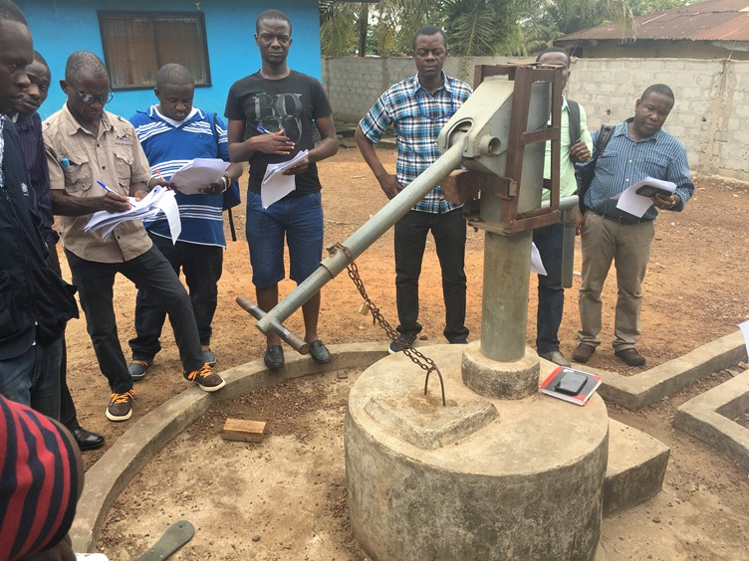

Version:
[XX]

Last Updated:
[DD/MM/YYYY]

Contents

Overview of the Water Safety Plan Steps 3

1 Water Safety Plan Team (Step 1) 4
2 Water System Description (Step 2) 6
3 Hazard and Control Measure Identification, Risk Assessment & Prioritization (Step 3) 8
4 Improvement Plan (Step 4) 14
5 Monitoring Plans (Step 5) 18
5.1 Operational monitoring plan 18
5.2 Verification monitoring plan 24
6 Water Safety Plan Documentation, Review and Improvement (Step 6) 25
6.1 Management procedures 25
6.2 WSP review/revision meetings 25
6.3 WSP supporting programmes 26

Annex 1 Emergency Response Plan Template 27
Annex 2 Standard Operating Procedure Template 28
Annex 3 WSP Assessment Template 29

Important note:

Please print additional sheets as needed to complete each step.

Overview of the Water Safety Plan Steps

The following figure gives a summary of the steps (or tasks) involved in the WSP process.
This WSP template follows each of these steps in the same order.

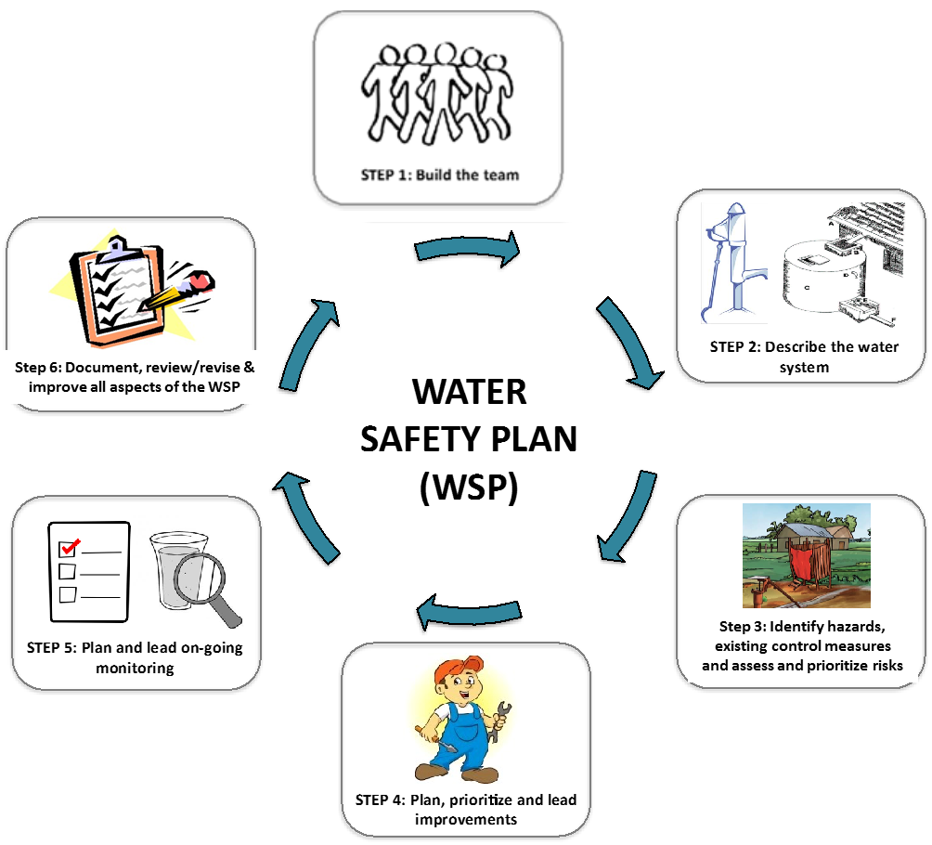

Water Safety Plan Team (Step 1)

Key action: Document the details of the WSP team members and outline their key
role and responsibilities.

The core duties of the WSP Team are as follows:
- Create a village map showing drinking water sources and fill in the system information table and fill in the system description table (STEP 2)
- Identify hazards and assess the effectiveness of existing control measures, and assess and rank risks to water safety from the catchment to consumer (STEP 3)
- Plan, prioritize and lead improvements to water system components (STEP 4)
- Plan and lead on-going monitoring of water system components including household practices (STEP 5)
- Document management procedures and meet routinely to check that WSP activities are being carried out as planned and the WSP is working effectively, and to make updates and changes to the WSP if necessary (STEP 6)
- Plan and lead on-going awareness raising activities to educate staff, households and the general community about safe water practices (STEP 6).

[Add additional responsibilities as required]

WSP Team Table:

Name | Designation | Organization | Role on the WSP Team | Contact information
Ms. X | Caretaker | Water & Sanitation Management Team | Water supply system operation and maintenance | Ph. 01 234 5678 email@email.com

Note: Use additional sheets as needed.

Water System Description (Step 2)

Key action: Briefly describe in words, and in a drawing, the water system from the catchment/source right through to the
point of use by the consumer.

Describe the general conditions of the catchment (e.g. forested, agricultural, protected etc.), the source(s) of water (e.g. dug well, borehole, pond, river etc.) and the number of people served | Describe how people collect and transport the water (e.g. tap, stand/carry by hand, pump to house etc.) | Make a list of the different ways people treat (e.g. boiling, filtration, chlorine tablets) and store (e.g. in a household tank, jerry can, open bucket etc.) drinking-water at the household level (if practiced)
Catchment:  - Human settlements with latrines (open defecation free community)  - Small-scale agriculture (pig farming, cattle farming)  - Roads (unsealed)  - No protection zones currently exist around bore area  - Seasonal flooding (inundating bore site).  Source:  - Bore water (shallow [5 m deep]; hand pump)  - Rain water harvesting (wet season only)  - Serves approx. 15 households. | Collection by consumers at bore hole (via hand pump).  Consumers collect water in open buckets to bring back to household. | No household treatment.  Household water stored in large open ceramic pots (no lid generally), on ground level. Pots are typically dedicated to water storage only.  Use of dipping tool varies (e.g. cup, hand, ladle).
Map of the water supply system

Draw a basic map of the water supply system. Include any activities in the catchment (e.g. agriculture, industry, human settlements), the source(s) of the water (e.g. well, river, bore), any treatment steps (e.g. filtration, chlorination), any storage or distribution infrastructure (e.g. tanks, pipelines), any collection points (e.g. tap stands), household water treatment and storage practices and any other information that may be relevant to water quality and hazard identification.

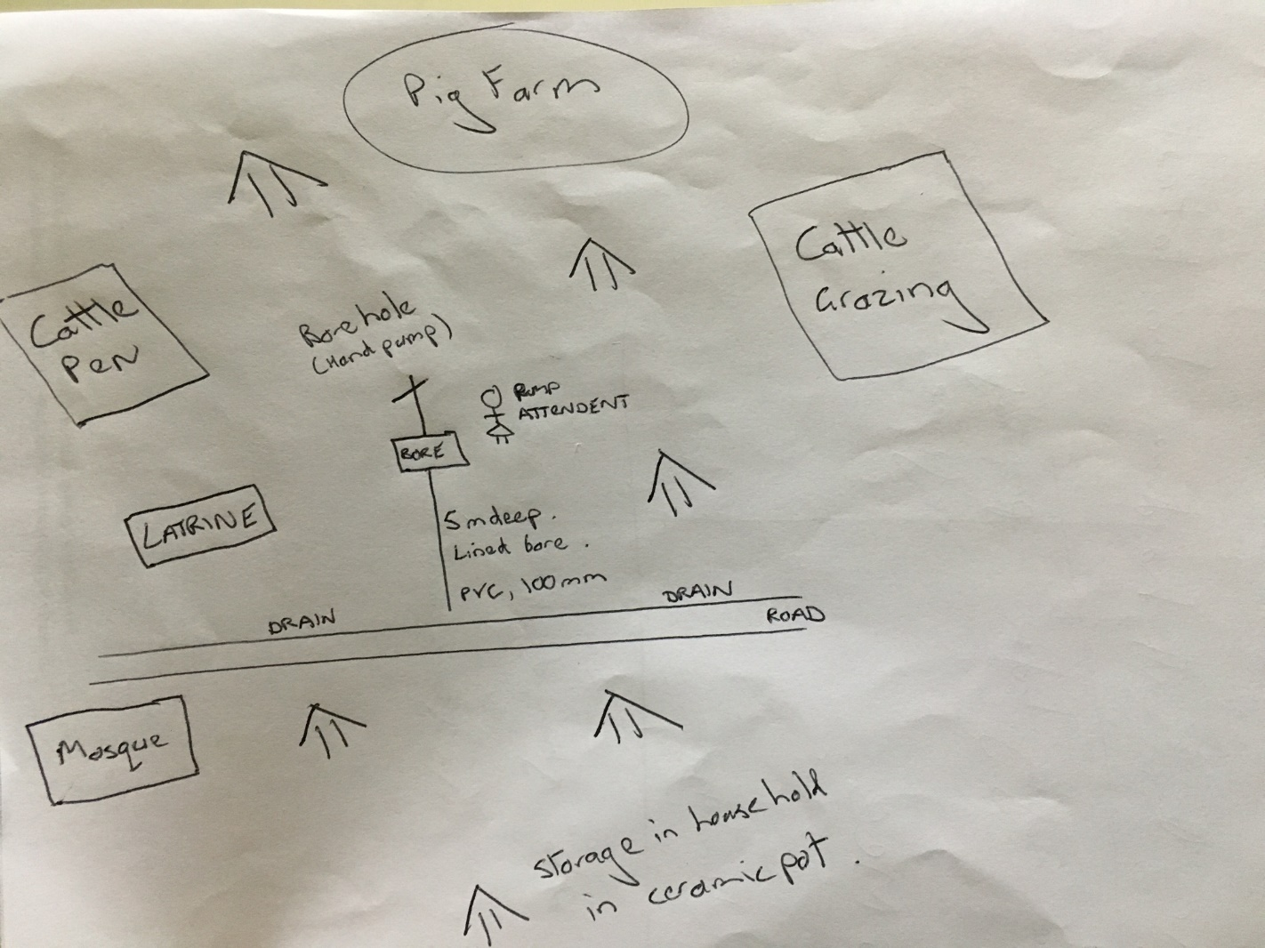

Hazard and Control Measure Identification, Risk Assessment and Prioritization (Step 3)
Key action: At each step of the water system, identify the possible dangers to water safety (i.e. hazards/hazardous events) that may impact water quality and community health. Assess the effectiveness of any existing control measures that are in place to manage these risks. Consider how important each risk is to water safety and rank the significance of each risk accordingly.

Risk assessment approach (descriptive risk assessment):

The WSP team should consider how likely a hazardous event is to occur and how serious it might be (given the effectiveness of the existing control measures), and assign a risk level.

Definition of risk level:

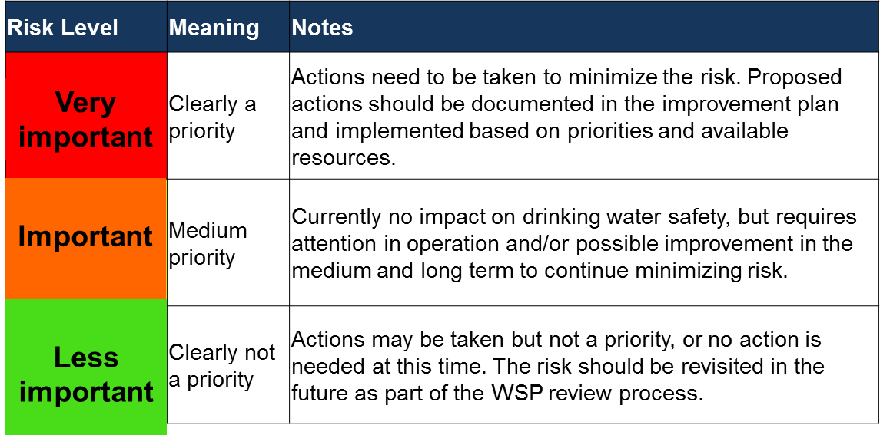

Note: Use additional sheets as needed.

Column 1 | Column 2 | Column 3 | Column 4 | Column 5
What can go wrong?  List what hazardous events could happen that might introduce hazards to your system and may make your drinking-water unsafe. | If this does go wrong, what hazard(s) might be introduced into the water?  M = Microorganisms  C = Chemicals  P = Physical  Q = Loss of quantity. | What existing control measures (i.e. barriers to contamination) are in place to prevent this (if any)?  If present, are the control measures working effectively? | How important is this event to water safety (i.e. how often is it likely to happen and what are the consequences if it does happen)?  Very important: requires urgent attention and action  Important: requires attention and action may be taken  Less important: no action required at this time. | Are additional control measures needed?  If yes, please state what additional control measure(s) are needed and include in Section 4.
Catchment/source
Contamination of the bore water from animals defecating around the bore site and infiltration after heavy rain. | M | Cattle pen enclosure (fence).  Cattle pen is newly constructed and of good materials and is effective at keeping animals contained. | Important.  Low likelihood: cattle are unlikely to escape from the pen once the gate is locked; gate is checked each night by the farmer.  Severe consequences: cattle dung has a high concentration of harmful microorganisms. | No.
Catchment/source (continued)
Collection/transport
Collection/transport (continued)
Point of use (household treatment and storage)
Contamination of household storage container during flood event due to storage on ground level. | M  P | None | Very important.  High likelihood: has been observed each year in low lying areas during major flood events.  Severe consequences: flood waters contain harmful microorganisms that can cause illness. | Yes.  Household awareness and education programme on safe water treatment/storage/ handling practices during flood events.
Point of use (household treatment and storage; continued)

Improvement Plan (Step 4)
Key action: Document the details of the additional control measures needed that were identified in Step 3 (Column 5).

 | What improvement is needed?  (From Column 5 of the  table in Section 3) | What is the priority level? (High/medium/low) | Who is responsible for coordinating the completion of this improvement? | How much is it estimated to cost? | Planned  start date | Planned finish date | Actual  completion date
1 | Develop community education and awareness programme for safe household treatment/storage/handling during flooding events. | High | Water and Sanitation Management Team Chairman | 1,000 GHS | 1 Oct. 2016 | 1 Dec. 2016 | In progress
2

3

4

5

6
7
8
9
10
11
Note: Use additional sheets as needed.

Monitoring Plans (Step 5)
Key actions: Document the details of the plan for (1) monitoring of the existing control measures identified in Step 3 (Column 3; i.e. operational monitoring plan) and (2) verifying that the WSP is working effectively (i.e. verification monitoring plan).

Operational monitoring plan (use additional sheets as needed)

Control measure  (from Column 3 in Step 3) | How will this existing control measure be monitored/inspected? |  | When is the control measure considered to be not working? | What needs to be done if the control measure is not working?
Cattle pen enclosure | What needs to be monitored? | Condition of the cattle pen enclosure fence | When the cattle pen fence/gate is damaged or broken. | - Notify WSP team leader and farmer  - Repair fence/gate  - Round up loose animals if necessary  - Inspect bore site for possible contamination or damage
 | How will it be monitored? | Visual inspection
 | When will it be monitored? | Weekly
 | Where will it be monitored? | At the cattle pen
 | Who will monitor it? | Caretaker
 | What needs to be monitored?
 | How will it be monitored?
 | When will it be monitored?
 | Where will it be monitored?
 | Who will monitor it?
 | What needs to be monitored?
 | How will it be monitored?
 | When will it be monitored?
 | Where will it be monitored?
 | Who will monitor it?
 | What needs to be monitored?
 | How will it be monitored?
 | When will it be monitored?
 | Where will it be monitored?
 | Who will monitor it?

Control measure  (from Column 3 in Step 3) | How will this existing control measure be monitored/inspected? |  | When is the control measure considered to be not working? | What needs to be done if the control measure is not working?
 | What needs to be monitored?
 | How will it be monitored?
 | When will it be monitored?
 | Where will it be monitored?
 | Who will monitor it?
 | What needs to be monitored?
 | How will it be monitored?
 | When will it be monitored?
 | Where will it be monitored?
 | Who will monitor it?

Control measure  (from Column 3 in Step 3) | How will this existing control measure be monitored/inspected? |  | When is the control measure considered to be not working? | What needs to be done if the control measure is not working?
 | What needs to be monitored?
 | How will it be monitored?
 | When will it be monitored?
 | Where will it be monitored?
 | Who will monitor it?
 | What needs to be monitored?
 | How will it be monitored?
 | When will it be monitored?
 | Where will it be monitored?
 | Who will monitor it?

Control measure  (from Column 3 in Step 3) | How will this existing control measure be monitored/inspected? |  | When is the control measure considered to be not working? | What needs to be done if the control measure is not working?
 | What needs to be monitored?
 | How will it be monitored?
 | When will it be monitored?
 | Where will it be monitored?
 | Who will monitor it?
 | What needs to be monitored?
 | How will it be monitored?
 | When will it be monitored?
 | Where will it be monitored?
 | Who will monitor it?

Control measure  (from Column 3 in Step 3) | How will this existing control measure be monitored/inspected? |  | When is the control measure considered to be not working? | What needs to be done if the control measure is not working?
 | What needs to be monitored?
 | How will it be monitored?
 | When will it be monitored?
 | Where will it be monitored?
 | Who will monitor it?
 | What needs to be monitored?
 | How will it be monitored?
 | When will it be monitored?
 | Where will it be monitored?
 | Who will monitor it?

Verification monitoring plan (use additional sheets as needed)

What needs to be checked? | What locations will be checked? | How often? And how many samples will be taken? | Who will do the checking? | What is the target outcome? | WSP team member to report the outcome to?
Water quality testing (compliance monitoring) (e.g. E. coli, faecal coliforms, turbidity)
E. coli | Household storage containers | 1 sample per month | Environmental Health Assistant | 0 E. coli/100 mL | WSP Team Leader
Sanitary inspection (e.g. at source, collection point, household etc.)
Sanitary condition | Bore site | 1 survey per month | Environmental Health Assistant | “Low” risk score | WSP Team Leader
 | Household collection/storage containers | 3 households per month | Environmental Health Assistant | “Low” risk score | WSP Team Leader
WSP implementation (e.g. WSP assessment [see Annex 3])
Implementation of WSP | Whole WSP (source to household) | 1 audit per year | District Environmental Health Officer | Audit pass | WSP Team Leader
Consumer satisfaction (e.g. satisfaction survey)
Level of consumer satisfaction | Households | Performed once per year; covering 10 households | District Environmental Health Officer | “High” level of customer satisfaction received from 80% of households | WSP Team Leader

Water Safety Plan Documentation, Review and Improvement (Step 6)
Key actions: Review the WSP (both routinely and following incidents/emergencies) to check that it is up-to-date and accurate.
Revise the WSP as necessary. Document key management procedures and response plans.

Management procedures
Templates for Emergency Response Plans (Annex 1) and Standard Operating Procedures (Annex 2) may be found in the annexes. Complete these as required and store in a folder alongside the WSP, and in the field as required.

WSP review/revision meetings
Date of WSP review meeting | Reason for meeting (e.g. routine or post incident/emergency) | Participants present | Topics discussed | Key outcomes/ actions | Person responsible | Date completed
1 Oct. 2016 | Routine monthly meeting. | Mr. X  Ms. Y  Ms. Z | Status of improvement plan implementation. | District Technical Team to be updated on improvement plan implementation | Mr. X | Open
Note: Use additional sheets as needed.

WSP supporting programmes

Key action: Document the details of a supporting programme for on-going education & awareness raising for the WSP team & community.
What specific awareness-raising activity will be carried out? | How often will the activity be carried out? | Name of the person in charge of this activity?
e.g. Water safety awareness during an emergency, such as a flood; Household sanitation and hygiene; Community sanitation and clean-up campaigns; Household water treatment and safe storage; School education programmes; Water treatment operator/caretaker training programmes; Emergency drills for flooding events | Six monthly | Ms. Y
Note: Use additional sheets as needed.

Annex 1 Emergency Response Plan Template

To document your actions in response to an emergency situation, use the following template (Note: use additional sheets as needed).

Possible emergency situation(s) | Detection of faecal contamination (E. coli) in the treated water supply.
Person(s) to be notified and method of notification | WSP team leader (Ph. 12345678)  Public health officer (Ph. 12345679)  Community leader (Ph. 12345670)  District health officer (Ph. 12345677)
Method of notifying the community | Public announcement.  Sign at tap stands.  Door to door visits.
Source of alternative water supply | None available.  Community to be advised to boil the water before consumption until further notice.

Annex 2 Standard Operating Procedure Template

To document step-by-step instructions for carrying out routine tasks in your water supply system, use the following template.

Task to be completed | Frequency | Instructions | Person responsible
Inspection of the cattle pen | Weekly | - Walk around the perimeter of the cattle  - Check the fence for signs of damage  - Check the gate is structurally sound  - Check the gate padlock is in good condition and working order  If the fence or gate/lock are in need of maintenance or repair report to the WSP team leader immediately to coordinate maintenance/repair. | Caretaker

Annex 3 WSP Assessment Template

To carry out an assessment of the WSP, use the following template.

General information
District:

Water supply name:

Date of assessment:

Assessor(s):

Water supply type:
(e.g. point source [well, spring etc.], piped water supply, any treatment etc.)
Primary contact for the water supply system (name, contact details)
Overall WSP assessment summary:
(to be completed at the end)

WSP Assessment
# | Question | Assessment  (Good/Average/Poor) | Comments/Areas for improvement  (include reasons for your assessment mark and list any possible ways in which this area can be improved)
1 | Is the WSP team list current?
2 | Is the system description accurate and up-to-date?
3 | Is the hazard identification, control measure assessment and risk assessment understood and thorough?
4 | Is the improvement plan up-to-date and being implemented?
5 | Is operational monitoring being carried out as per the plan?
6 | Is verification monitoring being carried out as per the plan?
7 | If in use, are standard operating procedures and emergency response plans appropriate and being followed?
8 | Is the awareness raising plan appropriate for the needs of the staff/community and being implemented?
9 | Are the WSP team meeting routinely and the WSP being revised as appropriate?

-------------------------------------- -------------------------------------------------------------
Date Signature of assessor(s)

