Water Safety Plan
[Name of water supply system]

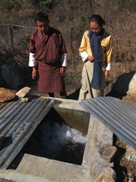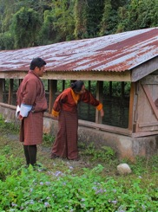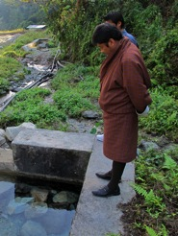

Last Updated:
DD/MM/YYYY

Note to Supplier:
The text and tables included in this WSP template are intended to be used as examples only. In all cases, the supplier should review and revise the material provided to reflect system-specific conditions. Areas flagged in blue text indicate areas where special attention is needed by suppliers to customize the example material provided.

Table of Contents

1 Introduction 1
2 Water Safety Plan Team 1
2.1 Roles and responsibilities of the core WSP team 1
2.2 WSP team membership 1
3 System Description 2
3.1 Intended users and uses 2
3.2 Drinking water quality standards 2
3.3 System diagrams 2
3.4 Additional system information 3
4 Hazard Identification and Risk Assessment 5
4.1 Key terminology 5
4.2 Risk assessment approach 5
4.3 Hazard identification and risk assessment 7
5 Improvement Plan 8
6 Operational Monitoring Plan 9
6.1 Water quality testing 9
6.2 Visual inspections 10
7 Verification Monitoring Plan 15
7.1 Compliance monitoring 15
7.2 Consumer satisfaction 16
7.3 WSP auditing 16
8 Management Procedures 16
8.1 Standard operating procedures (SOPs) 16
8.2 Emergency response plan 17
9 Supporting Programmes 17
9.1 Operator training 17
9.2 Consumer education 18
10 Review & Revision 18
10.1 Quarterly review 18
10.2 Annual review 18
10.3 Post-incident review 18
Appendix A – WSP team meeting minutes form 19
Appendix B – Record of completed improvement works 20
Appendix C – Consumer comments register 21
Appendix D – Audit checklist 22
Appendix E – Education & training log sheet 23

Introduction
A Water Safety Plan (WSP) is widely considered to be the most effective means of consistently ensuring the safety of a drinking water supply. A WSP follows a comprehensive risk assessment and risk management approach that encompasses all steps in water supply, from catchment to consumer, and it is a valuable tool to help suppliers effectively operate and manage the water supply system.

Water Safety Plan Team

Roles and responsibilities of the core WSP team

- Walk the complete system (from catchment to consumer)
- Develop a detailed system description (including diagrams)
- Identify relevant hazardous events/hazards and control measures and assess risk
- Develop and implement an improvement plan
- Develop and implement monitoring plans
- Develop standard operating procedures and an emergency response plan
- Develop and implement supporting programs (e.g. operator training)
- Meet at least quarterly to review WSP-related records
- Review and update the WSP at least annually
- Maintain records of all WSP-related activities (e.g. monitoring results, meeting minutes)

WSP team membership

Name | Organization | Job Title | Role on the WSP Team | Contact Information

System Description

Intended users and uses
The water supplied is intended for consumption, food preparation, bathing and laundry. Intended consumers do not include individuals or industries with special water quality needs. These groups are advised to apply additional treatment as appropriate.

Drinking water quality standards
Drinking water quality shall be in accordance with the World Health Organization’s (WHO) Guidelines for Drinking Water Quality (4th Edition).

System diagrams
The following diagrams are examples only and need to be replaced with system-specific diagrams. (Where system schematics, distribution system maps, etc., exist elsewhere and it is not feasible to cut/paste them into the WSP document, they should be referenced in this section.)

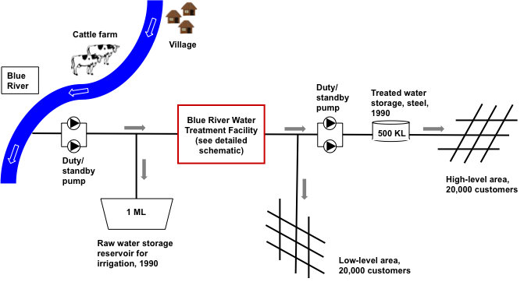

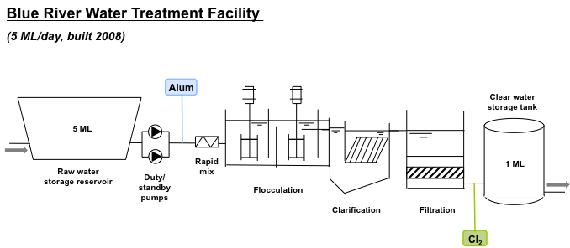

Additional system information

Type of source (surface water or groundwater)
Number of staff dedicated to water supply system operation and maintenance
Capacity of source/abstraction infrastructure
General description of catchment (forested, protected, industrial, residential, mixed use)
Specific catchment activities or developments that may impact water safety (upstream of intake)
Population served by the water supply system
Number of service connections
Hours of supply (daily)
Total consumer demand
Description of treatment works
Year of construction of the water supply system
Capacity of treatment plant
Any known treatment plant issues
Distribution pipeline information
% non-revenue water (% volume produced lost through leaks, illegal connections, etc.)
Any known treated water quality problems (e.g. issues with low chlorine or high microbial counts at certain locations, etc.)
Consumer practices

Hazard Identification and Risk Assessment

Key terminology

- A hazard is a biological, chemical or physical agent that has the potential to cause harm.
- A hazardous event is an event or situation that can introduce a hazard to the water supply system.
- Risk is the likelihood that a hazardous event/hazard will occur combined with the severity of the consequences.
- Control measures are activities or processes to prevent or reduce a hazardous event/hazard.
- Validation refers to reviewing evidence to determine whether or not the control measures can effectively control the hazardous event/hazard.

Risk assessment approach

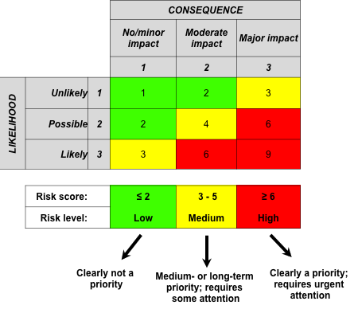

Likelihood level |  | Definition
1 | Unlikely | Could occur at some time but has not been observed
2 | Possible | Might occur at some time; has been observed occasionally
3 | Most likely | Will probably occur in most circumstances; has been observed regularly
Consequence level |  | Definition
1 | No/minor impact | Minor or negligible impact on water quantity or quality (e.g. aesthetic impact, not health related) for a small percentage of customers; some manageable disruptions to operation; rise in complaints not significant
2 | Moderate impact | Minor impact on water quantity or quality (e.g. aesthetic impact, not health related) for a large percentage of customers; clear rise in complaints; community annoyance; minor breach of regulatory requirement
3 | Major impact | Major water quantity or quality impact; illness in community associated with the water supply; large number of complaints; significant level of customer concern; significant breach of regulatory requirement

Hazard identification and risk assessment
 |  |  |  | Are controls effective? |  |  |  | Risk assessment |  |  |  | Additional control needed?
Process Step (catchment, source, treatment plant, etc.) | Hazardous Event (how a hazard could potentially be introduced) | Hazard (microbial, chemical, physical, etc.) | Existing control measures (measure in place to address hazard) | Yes | No | Somewhat | Validation notes (basis of control measure effectiveness decision) | Likelihood | Consequence | Risk score | Risk level | Yes | No | If yes, proposed controls and Improvement Plan reference number (IP#) (further detailed in the improvement plan below)

Improvement Plan

IP# | Specific improvement action | Relevant hazardous event/hazard | Responsible party | Estimated Budget | Due date | Status update
 |  | (summarize from the risk assessment table above) | (individual accountable)
1
2
3
4

Operational Monitoring Plan
Operational monitoring is carried out by the supplier by visual inspection and water quality testing in accordance with the tables below to confirm that key water supply system components and control measures are working effectively.

Water quality testing
The table below describes the preferred monitoring plan, but monitoring is presently not performed as described due to a lack of testing equipment. As indicated in the improvement plan, equipment and training for test turbidity, chlorine residual and pH are needed before the monitoring plan can be implemented.
The supplier should customize the table below to reflect its own water quality monitoring programme.
 |  |  |  | (If applicable)
Where | What | When | Who | Critical limits (or target range) | Corrective actions if critical limits exceeded
Source (intake chamber) | Turbidity | Seasonally | Technician | Turbidity: <1000 NTU | Technician to divert flood water immediately & suspend raw water harvesting until turbidity level drops below critical limit.
Clearwater tank (outlet) | pH | Weekly | Technician | pH: 6.5-8.5 | Technician to investigate change in pH.
 | Turbidity |  |  | Turbidity: <5 NTU | Technician to confirm WTP performance and check for leaks/breaks in pipeline.
 | Cl₂ |  |  | Cl₂: 0.6-0.8mg/L | Technician to check and adjust chlorine dosing as needed.
Customer taps (5 taps each time) | pH | Weekly | Technician | pH: 6.5-8.5 | Technician to investigate change in pH.
 | Turbidity |  |  | Turbidity: <5 NTU | Technician to confirm WTP performance and check for leaks/breaks in pipeline.
 | Cl₂ |  |  | Cl₂: 0.2-0.6 mg/L | Technician to check and adjust chlorine dosing as needed.

Visual inspections
The supplier should customize the table below to reflect its own system components and visual inspection programme.

What to inspect | Inspection frequency | Who to inspect | Critical limit (or target condition) | Corrective action if critical limit is exceeded
Intake
Blockages at the strainer of the inlet pipe | Weekly | WTPO | Strainer free of debris and inflow unaffected | WTPO to immediately remove the debris suspended at the strainer
Slow Sand Filter (SSF)
Water level (head) | Daily | WTPO | X feet below the top of the SSF basin | Technician to investigate and, if needed, remove the sediment layer as per the SOP
ETC
ETC | ETC | ETC | ETC | ETC

Verification Monitoring Plan
Verification monitoring is carried out as described below to confirm that drinking water quality standards are being met, consumers are satisfied and the WSP continues to be implemented and updated appropriately.

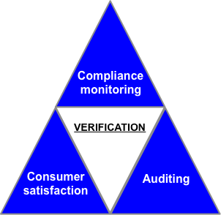

Compliance monitoring
Health workers perform water quality testing to confirm compliance with drinking water quality standards in accordance with the table below. It is the responsibility of the supplier to obtain a copy of the compliance monitoring results from the health workers and respond to adverse results as appropriate. (This compliance monitoring programme by health workers complements the operational monitoring programme carried out by the supplier, which is detailed above.)

The supplier should customize the table below.
Sampling frequency: | Quarterly
Parameter tested: | Faecal coliforms
Target value: | 0 cfu/100mL
Sampler: | District health technician
Sampling locations: | Source, all storage reservoirs, taps/HH storage containers (5 pairs)
Samples tested at: | District health laboratory

Consumer satisfaction
The supplier should describe how consumer satisfaction will be monitored (e.g. consumer comments register as shown in Appendix C, annual household surveys, etc.).

WSP auditing
The WSP should be audited once in two years by an external audit team composed of representatives from Ministry of Works and Human Settlement, Department of Public Health, and National Environment Commission. Internal auditing should be lead by the WSP team leader annually. An example audit checklist is provided in Appendix D.

Management Procedures

Standard operating procedures (SOPs)
The supplier should document SOPs for all key operational tasks, such as:
- Filter operation and maintenance
- Chlorination
- Jar testing
- Water sampling
- Water testing (for various parameters)
- Storage tank cleaning
- Pipeline repair practices
- Pump operation and Maintenance
- Etc.

If preferred, the supplier could document SOPs in a table format as shown below. (Note that the table is an example only. The content would need to be revised by the water supplier.)

Key operational task | Standard operations and maintenance | Responsible party
Slow sand filter operation and maintenance | Limits filter loading (or WTP production) to XX L/s. When the filtration rate begins to slow and the head level rises, remove the top layer (~X cm) of sand.  Every X years, remove, wash, and replace all sand with sand conforming to XX specifications from XX supplier.  XX volume of water should be filtered to waste following any filter maintenance to prevent dirty water from entering the system when the filter is returned to service after maintanence. | In-charge and caretaker
Chlorine batching | Wearing all recommended personal protective equipment, (including mask, gloves and eyewear), mix X kg of chlorine powder (X%) into X liters of water. Mix thoroughly. Allow to settle for X minutes such that all sediments settle to the bottom. Decant the liquid solution into the chlorine dosing tank, taking care not to disturb the sediments at the bottom. | Operator
Gravity chlorine dosing | Do not allow the chlorine solution to drop below level X in dosing tank. Check gravity injection lines daily to ensure there are no blockages.  (Need to add guidance on how to determine appropriate valve setting at the outlet of the chlorine dosing tank as a function of the rate through the water treatment plant to apply the dose required to achieve the target chlorine residuals at the outlet of the contact tank and throughout the distribution network. This will require careful consideration, calculation and possibly additional training. Chlorine residual testing equipment is critical to confirming that the appropriate dose has been applied.) | Operator
Storage tank cleaning | Annually, close the inlet, drain out the water, dry the tank for one day, clean the walls and remove the silt manually. The consumers will be notified through the local TV channel or BBS two days ahead of the tank cleaning date. | Caretaker and municipal technician

Emergency response plan
The supplier may wish to add more details to the example emergency response plan provided below. The information in the table below should be considered a minimum.

Potential water quality incidents or emergencies (e.g. treatment chemical overdose, microbiological contamination, etc.)
Persons to be notified (from within the supplier as well as external agencies), including contact details
Person responsible for notifying external agencies, including contact details
Plan for disseminating alert to consumers (when necessary), including responsible parties and method of communication

Supporting Programmes

Operator training
The supplier should describe its operator training programme and record-keeping practices. An Education and Training Log Sheet is provided in Appendix E as an example.

Consumer education
The supplier should document its awareness and educational programmes and record-keeping practices. An Education and Training Log Sheet is provided in Appendix E as an example.

Review & Revision

Quarterly review
The WSP team will meet at least quarterly to ensure that the WSP is being carried out as planned and is effective, and the WSP team will keep records/minutes for all meetings. Major items for review and discussion during quarterly meetings are:
- Improvement plan implementation
- Operational monitoring records
- Verification monitoring records

Annual review
The WSP team will meet annually to thoroughly review and revise the WSP to keep it up-to-date, and the WSP team will keep records/minutes for all meetings. Possible reasons for WSP revision include:
- Changes to the WSP team
- Changes to land use in the catchment
- Any system changes (source, treatment, storage, distribution, population served, etc.)
- New hazardous events or control measures
- Updates or changes to the improvement plan
- Changes to the operational or verification monitoring plans
- Changes to management procedures or supporting programmes

Post-incident review
In addition to scheduled WSP reviews, relevant components of the WSP will be reviewed following incidents or emergencies and revised as appropriate to avoid recurrence and to improve response.

Appendix A – WSP team meeting minutes form

Date of WSP team meeting:

Meeting participants:

Topics discussed and outcomes of meeting:

Date, time and location of the next WSP team meeting:

Appendix B – Record of completed improvement works

Improvement undertaken | Relevant hazardous event/hazard (from the risk assessment table) | Date completed | Actual cost

Appendix C – Consumer comments register

COMMENT |  |  |  | ACTION
Date received | Comment received by | Specific comment (including consumer name if applicable) | Relevant location | Date action taken | Action taken by | Specific action taken | Recommendations for further action

Appendix D – Audit checklist

☑ | = satisfactory | ☒ | = needs improvement
- WSP Team member list current

- System description current/accurate

- Hazard ID and risk assessment table current and thorough

- Improvement plan current and improvement works being carried out

- Operational monitoring carried out as planned

- Verification monitoring carried out as planned

# of faecal coliform tests conducted on treated water in past 12 months: _________

# of non-zero faecal coliform results from treated water in past 12 months: _________

# of any other tests carried out from treated water in past 12 months: __________

- SOPs current and being followed

- Emergency response plan current

Signature of auditor |  |  |  |  | Date

Appendix E – Education & training log sheet
Training date(s) | Person(s) trained | Course/programme | Trainer/training body

Improvement Plan reference number from the hazard identification and risk assessment table
As planned improvements are implemented, they are removed from this Improvement Plan and documented in the “record of completed improvement works” (see Appendix B)
Test results for all treated water must comply with drinking water quality standards (i.e. WHO guidelines)
Source water samples are not required to comply with drinking water quality standards

